**The aftermath of Hurricane Harvey**

Vivek Panchal  
 Information Science and Technology  
 Rochester Institute of Technology  
 Rochester, New York, USA  
 vp2890@rit.edu

ABSTRACT

GIS is a computer system that allows us to capture, process and visualize topographical data about the Earth’s terrain in form of multiple, separate layers of information pertaining to a common region of focus. It is quickly becoming the de facto technology for processing location-based data and gaining insights from location-based data. It has also found its place in the disaster management process, where it is frequently used to develop strategies and implement emergency measures for vulnerable regions through phases like ‘mitigation’ and ‘preparedness’. Mapping and analyzing data concerning hurricanes, floods and wildfires are some areas in which most of the research and work is focused right now. In this project, analysis and visualizations have been performed using data collected from the aftermath of hurricane Harvey. After originating in the Caribbean Sea, the hurricane made landfall in Texas and wreaked havoc as a Category 4 storm. While it caused wide-spread damages due to extreme winds, most of the destruction was caused by heavy-hitting rains and unprecedented levels of flooding. In addition to huge damages to the infrastructure, the storm caused a total of 107 confirmed deaths and many more injuries. In this project, the main aim of the initial analysis was to analyze the effects of the hurricane-induced flooding on the measures and efforts taken for evacuation via roadways. This analysis was centered mostly on areas where the infrastructure was affected due to flooding severely. Another analysis was made to get a sense of the environmental impact the severe flooding had on the local water bodies and reservoirs, due to cross-contamination by exposure to effluents, bio and industrial waste and external water flow.

KEYWORDS

Hurricane Harvey, Spatial analysis, Flooding.

**1** **PROBLEM DOMAIN**

This project explores the use of cases of GIS analysis in the domain of disaster management and relief. It is very essential for everyone to have insights about such catastrophic events. Hence this is the reason I chose the domain of disaster management and relief to understand the aftermath of Hurricane Harvey.

**2 PROBLEM DESCRIPTION**

Hurricane Harvey was a category four storm that hit Texas in the year 2017, which caused serious hazards. This hurricane caused a total loss of $125 billion [4]. Over seven days, 50 inches of rain was recorded in the areas affected by Hurricane Harvey. A major impact of this phenomenon was seen in the evacuation efforts, as the roadways became flooded in the areas that took the brunt of the hurricane. Furthermore, due to inland flooding across a large area, many inland water bodies and reservoirs were exposed to infiltration by water from other external sources. This caused a major issue of cross-contamination in the water bodies present in the affected regions.

3 GOALS AND OBJECTIVES

Florida is a state that lies at sea level and is inundated with marshlands and swamps. It’s the geographical position, and topography makes it quite prone to hurricanes and other such phenomena.

As my first objective, I will perform a multi-faceted analysis to gain insights on the effects of this disaster on the roadways and the damage faced by infrastructure in the profoundly affected areas.

My next objective was to perform an analysis to try and identify the waterbodies present in the terrain and cross-referencing them to the affected regions.

My third objective was to find Social Vulnerability index affected after Hurricane Harvey.

4 LITERATURE REVIEW

Geographic information systems can be used effectively to evaluate the aftermath after a natural disaster like Hurricane Harvey. In [1], the authors wanted to identify whether the water sources located in sub watershed with at least one potential source of environmental pollution nearby, in areas affected by Hurricane Harvey were polluted. This was a possibility as the floodwater could have mixed the polluted source into the water sources. To achieve this, the authors geocoded all the parks which were located in a sub watershed. These parks were then cross-referenced with the map of areas affected by Hurricane Harvey and the spatial analysis was done. This information helped in identifying the water sources that may have been compromised. Like Harris County, one of the areas affected by Hurricane Harvey is a low-lying area, the authors in [2] performed a GIS-based analysis to identify the flood-prone areas in Harris county. The authors accomplished this by creating a flood hazard map using GIS systems. Many factors such as Distance from Road, Distance from River, Elevation, Rainfall Intensity, Flow Accumulation, etc. were considered while developing the flood hazard map. This information can be used to implement better prevention methods. In [3], the authors ranked multi-day precipitation events from 1949-2018 and found that Hurricane Harvey topped the list. The main motivation for this study was the development of the “North Carolina Climate Risk Assessment and Resiliency Plan” of which a climatic science assessment was a component. Another reason to perform this study was that the authors wanted to better understand the climatology of large area-averaged extreme precipitation events. This study shows the intensity of hurricane Harvey and gives us an indication of the scale at which our preparations need to be in case of a similar event happening in the future.

5 METHODOLOGY AND RESULTS

**5.1 Analysis**

For my analysis, the first thing I wanted to know was about the path of the storm. After getting the dataset I explored the attribute table to get more information about it. The dataset which I used had information about the path, points, radius and wind swath storm had covered. The points were nothing but the dates on which storm had happened in that place. The line had the information about the route in which the storm had traveled, and radius had the information about how many portions of the area did it affect. Spatial analysis was performed on the dataset. I made use of graduated symbology to distinguish points, line, radius and wind swath [Figure 1].

**Figure 1: Storm Track of Hurricane Harvey**

**5.2 OBJECTIVE 1**

My first objective was to know more about the effect of the disaster on roadways and damage to infrastructure. The first step was to obtain a relevant dataset for this analysis. I made use of the points, lines and radius dataset of hurricane Harvey in addition to that I included the damage assessment dataset which was made available by FEMA. I used the national geographic world map as my base map as I wanted to create a heat map. I placed all the layers together and for the purpose of the heat map, I changed the symbology features of the dataset. I symbolized my layer using density through which the heat map was created. The heat map gave information about how sparsely or densely a particular portion was affected. After performing these steps, I came to know that the area of Houston Galveston was heavily affected. In addition to these, I inculcated the evacuation routes that were designed for hurricane Harvey. I made use of the dissolve tool under the analysis tab. The purpose of choosing the dissolve tool was because it makes the output more generalized [Figure 2].

**Figure 2: Heat Map of Hurricane and Evacuation Routes**

**5.3 OBJECTIVE 2**

My second objective was to find out the water bodies that were affected because of the hurricane. The dataset for this analysis was obtained from the hydro share. I used bound water area as the base in this case because, in hydrology, bound water is a thin layer of water surrounding mineral surfaces [5]. The visualization gave information about dams, stream gauges, and high watermarks. I made use of basic cartography principles for the analysis. Graduated colors were used to distinguish points [Figure 3].

**Figure 3: Hydrology of Hurricane Harvey**

**5.4 OBJECTIVE 3**

For my final objective, I wanted to know more about the social vulnerability index that was affected by Hurricane Harvey. Social vulnerability refers to the resilience of communities when confronted by external stresses on human health, stresses such as natural or human-caused disasters, or disease outbreaks [6]. There were many attributes present in the social vulnerability dataset. I picked estimated housing units that were affected by hurricane Harvey. I added a layer of evacuation route that was designed to evacuate people in need and heat maps to show the severity in various parts [Figure 4].

**5 DATASETS**

Spatial analysis, Cartographic analysis, and networking analysis will be used, which will help me in analyzing the aftermath of Hurricane Harvey.

For infrastructure damage analysis, I will be using the following datasets [8][9][10][11][12][13][14][15][16].

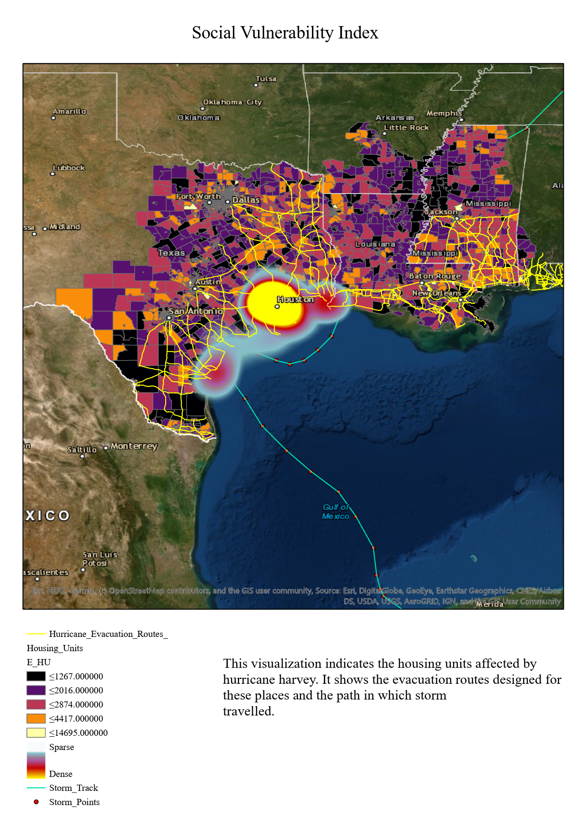

**Figure 4: Social Vulnerability Index of Hurricane Harvey**

**6 SUMMARY**

To summarize my analysis, I had set three objectives to analyze. Hurricane Harvey was a category four storm that hit Texas in the year 2017, which caused serious hazards. This hurricane caused a huge monetary loss and deaths. Damages were caused due to extreme wind, but the majority of destruction was caused due to rains and abnormal flooding. The first analysis gave me an insight into the path and radius covered by the hurricane. The result of the first objective informed that the area of Houston Galveston was heavily affected due to the hurricane and evacuation route that was designed to help people in need. The second objective was about getting information about hydrology. Storm surge, Wind swath, High watermarks, Dams endorsed more information about the hurricane. The primary impact of Hurricane Harvey was disastrous flooding. Cities from LaGrange, TX, and Victoria, TX, to Lake Charles, LA, experienced widespread flooding that cut off road access to some locations for weeks [7]. My final objective was to obtain details about the livelihood disrupted because of the catastrophic flooding. I mapped three layers that showed the household units, the heat map of sparsely or densely affected zones and the path in which storm traveled.

**7 CONCLUSION**

Events like Hurricane Harvey tell us how we as humans have failed to take care of the environment. Climate change was one of the important factors that worsened the rainfall, flooding, and storm. Improper land management caused abnormal flooding’s. The absence of wetlands, forests, and grasslands which are replaced by nonporous surfaces decreased capacity to quickly recover from flooding. This kind of analysis tells us which area is more prone to hurricanes and safety measures should be taken in such places to avoid such events. We can also see how GIS help identify the waterbodies present in the terrain and how they can be cross- referenced with the affected regions.

8 FUTURE WORK

In my view, more analysis should be done in designing and mapping of evacuation routes and prediction models. More work is needed when it comes to GPS navigation as the travel apps during such events tend to send people in wrong routes. Waze a mobile app in partnership with Esri, sent notification to people about routes that were affected and routes that they should rather take. A detailed analysis should be done about what process did they undergo, and which algorithms were applied. In addition to that, factories and everything that can contaminate the water shouldn’t be constructed around water bodies. The reason being sewage and wastewater from such places can affect human health and aquatic animals.

REFERENCES

[1] Karaye, I., Stone, K. W., Casillas, G. A., Newman, G., & Horney, J. A. (2019). A Spatial Analysis of Possible Environmental Exposures in Recreational Areas Impacted by Hurricane Harvey Flooding, Harris County, Texas. *Environmental Management*, *64*(4), 381–390. DOI: 10.1007/s00267-019-01204-4

[2] Mukherjee, F., & Singh, D. (2019). Detecting flood-prone areas in Harris County: a GIS-based analysis. *GeoJournal*. DOI: 10.1007/s10708-019-09984-2

[3] Kunkel, K. E., & Champion, S. M. (2019). An Assessment of Rainfall from Hurricanes Harvey and Florence Relative to Other Extremely Wet Storms in the United States. *Geophysical Research Letters*, *46*(22), 13500–13506. DOI: 10.1029/2019gl085034

[4] K. Amadeo, “Hurricane Harvey Shows How Climate Change Can Impact the Economy,”The Balance. [Online]. Available: <https://www.thebalance.com/hurricane-harvey-facts-damage-costs-4150087>. [Accessed: 01-Mar-2020].

[5] “Bound water,” Wikipedia. 07-Aug-2018.

[6] “CDC’s Social Vulnerability Index,” 05-Sep-2018. [Online]. Available: <https://svi.cdc.gov/>. [Accessed: 01-Mar-2020].

[7] [Weather.gov](http://Weather.gov). (2018). August/September 2017 Hurricane Harvey. [online]Available at: <https://www.weather.gov/media/publications/assessments/harvey6-18.pdf> [Accessed 2 Mar. 2020].

[8] “City of Houston Hurricane Harvey Damage Assessment.” [Online]. Available: <https://kaggle.com/evgeniya1/city-of-houston-hurricane-harvey-damage-assessment>. [Accessed: 01-Mar-2020].

[9] “Hurricane Harvey Assessment of Potential Coastal Change Impacts: NHC Advisory 020, 700 AM CDT FRI AUG 25 2017 - [Data.gov](http://Data.gov).” [Online]. Available: <https://catalog.data.gov/dataset/hurricane-harvey-assessment-of-potential-coastal-change-impacts-nhc-advisory-020-700-am-25-2017>. [Accessed: 01-Mar-2020].

[10] “harvey data on data.world | 11 datasets available,” data.world. [Online]. Available: <https://data.world/datasets/harvey>. [Accessed: 01-Mar-2020].

[11] “CDC Social Vulnerability Index 2014.” doi: 10.4211/hs.c2df2a80b9d6490788704a24854f4879.

[12] “FEMA - Harvey Damage Assessments and Claims.” doi: 10.4211/hs.73c4f3dcff884a6da2c0982df769987c.

[13] “Harvey Basemap - Hydrology Map Data.” doi: 10.4211/hs.adb14c9c073e4eee8be82fadb21a0a93.

[14] “Harvey Flood Data Collections.” doi: 10.4211/hs.12e69ee668124fdf833b29b5167e03c3.

[15] “Hurricane Evacuation Routes.” [Online]. Available: <https://respond-harvey-geoplatform.opendata.arcgis.com/datasets/hurricane-evacuation-routes>. [Accessed: 01-Mar-2020].

[16] “Texas Basemap - Transportation Map Data.” doi: 10.4211/hs.106b38ab28b54f09a2c7a11b91269192.

Conference Name:ACM Woodstock conference

Conference Short Name:WOODSTOCK’18

Conference Location:El Paso, Texas USA

ISBN:978-1-4503-0000-0/18/06

Year:2018

Date:June

Copyright Year:2018

Copyright Statement:rightsretained

DOI:10.1145/1234567890

RRH: F. Surname et al.

Price:$15.00